AVDHESH SHARMA  GULAOTHI (BULANDSHAHR)  Phone: +91 – 9808109368  E-mail: avadh1984@ymail.com | 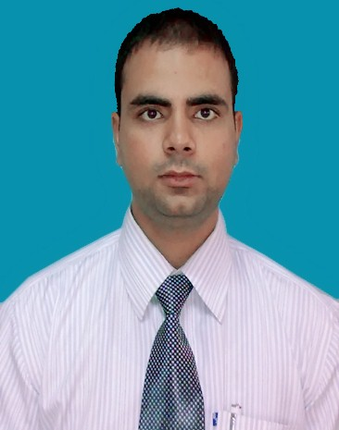

Objective | To attain high level of excellence in Operation, Customer Service, Quality Assurance and other Administrative functions, by optimum utilization of my personal & professional traits, capacity & capabilities, education & experience, while performing assigned responsibilities, in the related challenging job functions with constant endeavor to upgrade my knowledge & skills from time to time and to grab & strive to shoulder higher responsibilities retain, aim, & attain managerial – senior management position in a chosen organization with truth, devotion, sincerity & loyalty, given the desired trust, confidence and support from the Management, while functioning, performing.
Work Experience | ANSAL:  Worked for two years (from 1st/march/2005-28th/feb/2007) as a real estate adviser to  VANGUARD INFO SOL.PVT. LTD.:  Worked for two years (from 1st/march/2007-28th/feb/2010) as customer care executive and senior customer care executive for the us mortgage out bound process. This company is a reputed ISO 9001-2000 certified company providing world class services & solutions across the globe with a pronounced emphasis on the Middle East offering unstinted commitment to both clients and companies.  DEWAN PUBLIC SCHOOL.:  Worked for three years (from 15th/april/2010-20th/feb/2013 as senior teacher in computer department.  DISH TV:  Worked for three mounths (from jan 2015- march 2015) as a customer service associate in backend team.
Education  Technical Skills | - M.B.A SIET Pilkhawa GZB pertained in 2015.  - Diploma in Service Pro. For six months from HERO MIND MINE Noida in 2005.  - B.C.A. (I) Ajay Kumar Garg Engg,College Ghaziabad, India (2004).  - 12th & 10th from U.P board Allahabad in 2001 & 1999.  - Good in Microsoft office, outlook and all internet functioning’s. Good knowledge of all the operating systems and different software’s & hardware’s.  Tttttttttt
Professional Skills | Proficient in professional interpersonal relations, human behavior, verbal and written communiqués, liaison, personalized service. Capable of handling multifaceted assignments.
Interests and activities | Games – Cricket, listening to music, reading, traveling, interacting with people, meditation, Open, adaptable and responsive to new happenings.  Having good exposure and experience of extensive domestic and international Workings.
Languages | Can Read, Write and Speak fluently in Hindi, Little Spanish and English.
Personal Details  Strengths | Date of Birth: 16 JUL 1984, an active, efficient, mature / balance person with pleasing personality and sound health - physically and clinically fit.  Truthful, Responsible, Reliable, Innovative, Analytical, Creative, Enthusiastic with Initiative, Dedication & Devotion having Leadership qualities with excellent team spirit to assimilate with ease in personal & professional environment and make valuable contribution at work, with capacity to perform efficiently ensuring high degree of sincerity , integrity, stability towards establishment while nourishing better career / personal ambition in life.  (Avdhesh Sharma)

